1. Write a program in ARM7TDMI-ISA to find the sum of all the digits in an

32bit number.

.DATA

A: .WORD 0X12345678

SUM: .WORD

.TEXT

LDR R5,=A

LDR R6,=SUM

LDR R0,[R5]

MOV R1,#32

MOV R4,#0

MOV R8,#0

LABEL:

MOV R3,#0

MOVS R0,R0,LSR #1

ADDCS R3,R3,#1

MOV R7,R3,LSL R8

ADD R4,R4,R7

SUB R1,R1,#1

ADD R8,R8,#1

CMP R8,#4

BEQ LOOP

LOOP1:

CMP R1,#00

BNE LABEL

STR R4,[R6]

SWI 0X11

LOOP:

MOV R8,#0

B LOOP1

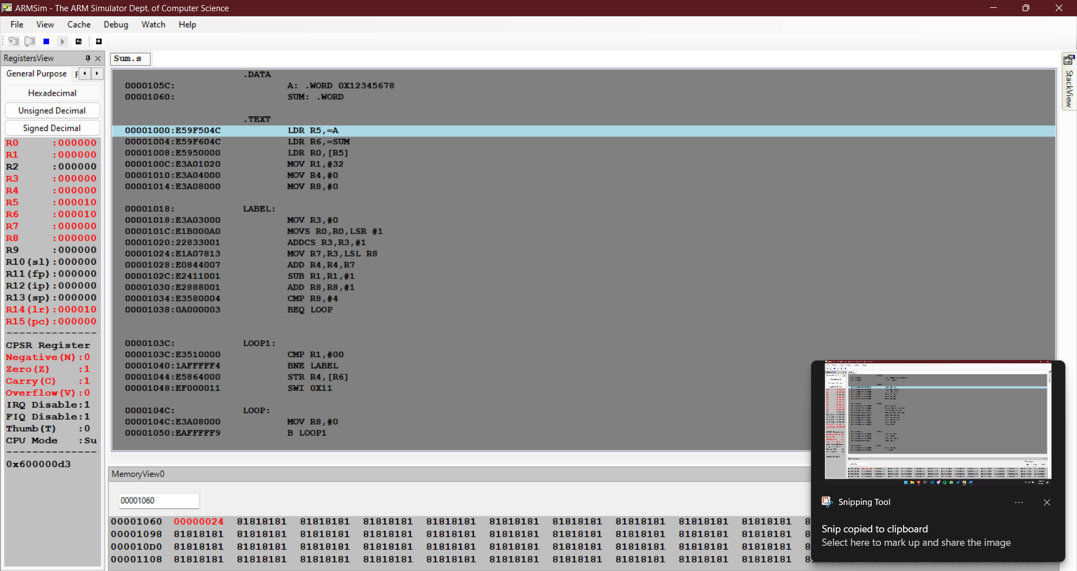

2. Write a program in ARM7TDMI-ISA to find the number of occurrences of a

given character in a string.

Example: Given string : My name is Bond.

Character : ‘n’.

Expected Output : Display 2 in a register.

.DATA

S: .ASCIZ "My name is Bond"

.TEXT

LDR R0,=S

MOV R2,#0

LOOP:

LDRB R1,[R0],#1

CMP R1,#'n'

BEQ ADD

LOOP1:

CMP R1,#0

BNE LOOP

B END

ADD:

ADD R2,R2,#1

B LOOP1

END:

SWI 0X011

